**DISCRIMINATION OF PUBLIC SERVICE QUALITY**

**IN KARANGSARI VILLAGE, KENDAL DISTRICT**

**Tri Lestari Hadiati1 and Jupriyono2, University of 17 August 1945 Semarang, Indonesia**

**PUBLIC POLICY INTERNATIONAL CONFERENCE (PPIC)**

**Shaping Indonesia’s Future:  Empowering Human Resources to Create Quality Public Policies and Welcoming All Parties**

**UNTAG Semarang, Indonesia**

Abstract

Officials in Karangsari Village, Kendal District, Kendal Regency, are often sued or complained about by the surrounding people, related to the lack of attention from local village government officials in working to manage public services. The progress of public services in Karangsari Village is still often questioned. This happens because there is discrimination or differences in the service of one person to another. The purpose of this research is to analyze the existence of discrimination in public services in Karangsari Village, what are the supporting and inhibiting factors.

The research method used is descriptive qualitative which produces a conclusion with a detailed description of event data or events in detail, and not just data in the form of numbers.Researchers searched for descriptive data about Discrimination in the Quality of Public Services in Karangsari Village, Kendal District, Kendal Regency to describe the data obtained from research findings, as well as observations in the process in the field. In this study, the researcher describes various data and characteristics or uniqueness obtained in the field. This study interviewed informants who were actors involved in managing governance in Karangsari Village and also service users

The results of the research and the results of the discussion regarding discrimination of excellent service quality in Karangsari Village, Kendal District, Kendal Regency, in conclusion, first, discrimination in the quality of public services in Karangsari Village, occurs in the Tangible Dimension, only certain people (relatives/family) are given the convenience of officials, not -the discipline of the apparatus present during working hours, the inconvenience of the service location. On the Reliability Dimension, in terms of public service standards that are not yet very clear, staff skills are still lacking, and there is no special expertise (computer) possessed by service personnel. In the Assurance Dimension, there is no guarantee/certainty regarding timeliness and costs for service users, so that it is profitable for relatives/family of officers, but detrimental for the local people. On the Empathy Dimension, even though they serve the people in a friendly and courteous manner, officials still prioritize the interests of their own families and relatives compared to the interests of the local people. The first two supporting factors that support the formation of excellent service in Karangasari Village are the enthusiasm given by officials to each other and the two leaders who continuously instill awareness to work sincerely and in accordance with the sensitivity of conscience. The first inhibiting factor is technological advances which are accelerating every year and people's demands for better, cheaper, more effective and efficient services are the basis for the government to improve processes in public services. There is no internet network at the Karangsari Village Office.

Keywords: discrimination, public service, tangibles dimension, reliability, responsiveness, assurance, empathy.

**1. INTRODUCTION**

Improving the quality of public (public) services provided by the central government and local governments is highly expected by the community (Inu, 2014; Ismail, 2013). Efforts to improve services have actually been carried out by the government for a long time through RI Law No. 25 of 2009 concerning Public Services in Article 4 explaining legal provisions that there is a close relationship between the people (users) and managers in public services (providers). In this global era with competition that is quite tight and full of obstacles, government officials are obliged to provide the best service to the community (Sedarmayanti, 2011; Sinambela, 2017). Public service becomes a strategic issue because the demand for quality performance of the bureaucracy in the public service sector has a broad impact on social, economic, legal, defense and political life.Agus, 2008). Public services in question cover various sectors such as the education sector, health sector, population administration, transportation sector, housing sector, social welfare, nutrition, electricity, and other basic food needs sectors.

Public services at the Karangsari Village Office, Kendal District, Regency are population administration services that involve making family cards (KK)Anggraini, 2017, Tasrif, 2019), ID cards, birth certificates, death certificates, moving letters and so on. As a public service institution at the Karangsari Village Office, officials try to serve by providing easy service assistance to meet the needs and interests of the people who come to the office.

In this study the research location was in the Integrated Service Office Unit (UPTD) Karangsari Village, Kendal District, Kendal Regency, on administrative aspects, population aspects, health aspects and administrative aspects, land aspects. This is a complex public service task as a servant of the community and at the same time a servant of the State (Simamora, 2015; Dinda, 2020).

**2. METHOD**

The research method or approach used is descriptive qualitative which produces a conclusion with a detailed description of event data or events in detail, and not just data in the form of numbers. This qualitative approach is a research procedure carried out to obtain descriptive data in the form of words, written or oral sentences from informants and observed behavior (Moleong, 2016). Qualitative methods rely on an observation, conducting interviews, and collecting materials from sharing documentation on research objects to obtain detailed data. This research is descriptive in nature, in making a structured, up-to-date and precise description of the reality at the research location, its characteristics and its relation to the social phenomena studied.

Researchers are looking for descriptive data about the quality of public services in Karangsari Village, Kendal District, Kendal Regency to describe the data obtained from research findings, as well as observations in the process of working in the field. In this study, researchers described various data and characteristics or uniqueness obtained in the field (Eva et al, 2020; Ratag et al, 2020, Megawati, 2021).

This study interviewed informants who were actors involved in managing governance in Karangsari Village and also service users. Researchers made observations as well as documentation as according to Sugiyono (2016), collected data and carefully observed the data used. The researcher directly made observations by looking at the research location related to the condition of the quality of public services carried out by officials in Karangsari Village, Kendal District, Kendal Regency.

**3. THEORETICAL FRAMEWORK**

In this study to accurately describe the phenomenon being observed, the definition used is described conceptually related to the main thoughts on events, incidents, a group/group or individual which is the center of attention of the researcher. Based on this concept, the researcher hopes to be able to extract the essence of his thoughts by using the designations of various events that are related to one another (Sugiyono, 2016). With an analysis of A. Pasuraman's Public Service Theory, Zeithaml & Berry (2011) has 5 dimensions, namely tangible, willingness, response, empathy, assurance, as shown in scheme 1 below.

Scheme 1. Dimensions of Public Service

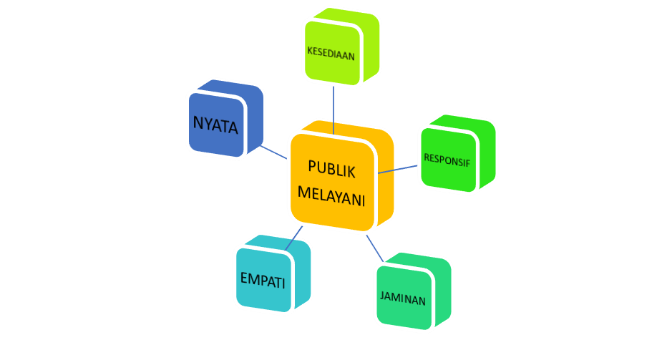

Source: Pasuraman, Zeithaml & Berry (2011)

**4. RESULTS AND DISCUSSION**

**A Quality of Public Services at the Karangsari Village Office**

Government officials in the Karangsari village area are often sued or complained about by the surrounding people regarding the lack of attention of local village government officials in managing public services. The progress of public services in Karangsari Village is still often questioned. This happens because there is discrimination or differences in service from one person to another, as in scheme 1 and see the following interview results.

"...often the service is not on time, the service is delayed from the officer's promise, this is very detrimental to the community who use the service," said informant 3

"Sometimes there are officials who are unfairly a bit picky in providing services to us, if you know an officer you can quickly service the mail," said informant 4.

"... what often happens is the establishment of a brotherly relationship because as a family between officers and the community, so they will be served first and the service can quickly make things easier," added informant 5.

Scheme 2. Dimensions of Public Service in Karangsari Village

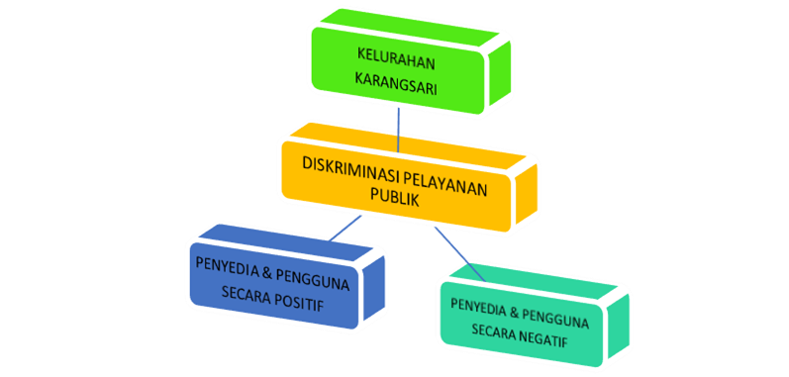

What happened in Karangsari Village was not in accordance with Permenpan and RB RI No. 15 of 2014 & Permenpan No. 17 of 2017 regarding Guidelines for Service Standards & Implementation of Public Services, which should be good, quality, quick to act, easy not complicated, affordable and measured time.

**a. Tangible Dimensions / Real (Intangible)**

The service staff at the Karangsari Village Office at work show that the appearance of the officers is good in serving the service user community, the waiting room looks good. However, all aspects in the tangible dimension have not been fully implemented by Karangsari village officials. Looking at these aspects, there is something lacking in the service process, as explained by the following informants.

"... officers still use shirts that do not use a collar as a substitute for uniforms when serving the community", said informant 3

“…. while waiting for the completion of a letter, in the waiting room there is no TV, magazines, newspapers," said informant 5.

"...even there is no photocopier, you have to go out to find a photocopying place," added informant 5.

"Still see that there are service personnel who prioritize their own interests rather than the needs of the community," said informant 6.

"Actually there are already requirements or service procedures in the service room and limited computer equipment in the service room, so officers have to take turns using the computer" explained informant 7.

All aspects of the tangib dimensione is an important point for achieving quality service so that as an apparatus must fulfill all its aspects, by fixing deficiencies that do not exist in a good service process, so that by improving the appearance of apparatus, space comfort, ease of service, time discipline, there is easy access to computers , printers, scanners), will enable the emergence of service quality in a real/realized dimension.

**b. Reliability**

The reliability dimension looks at the skills of the apparatus in providing fast and pleasant services. By carrying out this dimension, the apparatus must truly have reliability at work. The aspects that exist in the reliability dimension are the accuracy of the apparatus in serving, a true understanding of the existing service standards, the competence of the apparatus in using computers. Officer services for the people at the Karangsari Village Office have attempted to apply several aspects of the reliability dimension, namely regarding the accuracy of officers in serving, meticulous officers in carrying out service processes, dexterity in work.

However, it seems that there are still deficiencies in the implementation of the apparatus, the service standard at the Karangsari Village Office does not yet have clarity, as explained by the following informant.

"I haven't seen writing or schematics related to service standards on the walls of the waiting room in the service section," said Informant 1

"The skills and skills of the apparatus in using computers in the service room, it can be seen that the apparatus is not yet skilled in using computers, including printers and scanners," said Informant 2

"This inability is still visible from several officials who often ask for help from other officials to use the computer," added Informant 2

The reliability of human resources, especially in the service department in Karangsari Village, is still very limited, thus hampering the service process. Things like that should be an important point to maximize the performance of the apparatus, so that it runs as expected by the people. If the service apparatus has reliability and works well in serving the people, then the people do not have to wait long for the completion of an administrative matter.

**c. responsiveness**

Responsiveness dimensionis the behavior of officials who must be responsive at work and be able to work quickly, correctly and thoroughly in accordance with the specified deadline. This dimension of responsiveness includes various aspects, namely: responding to the needs of every citizen who comes, the apparatus provides services carefully, correctly and quickly, the apparatus provides services at the right time and all complaints from the people without exception are responded to by the apparatus.

In the service process in Karangsari Village, officials have tried to respond to service users in a friendly and kind manner, and service officials have tried to provide services quickly, precisely and carefully.But the facts are as the following informants respond.

“Fast service time has never happened before, because I am not satisfied with the long time it takes to complete a task. The response given by the service officer was not fast but still rather slow," said informant 6.

"Furthermore regarding complaints from service users, complaints from service users in Karangsari Village have started to get quite a bit of a good response," said Informant 7

"Public responses can be through "Mr. Head of Village Great Application" or by letter, complaint box, telephone, mass media and social media," continued Informant 8.

Suggestion boxes are not yet available in Karangsari Village so that people submit their complaints directly to service workers. Now service users can use technology to convey responses, as said by Informant 8.

Good quality service is apparatus service that can make people/customers feel happy or satisfied. On the other hand, apparatus with a fast and good response to the community is also an increase in the quality of service. If everything has been carried out properly and smoothly, both by the response of the apparatus as the provider and the people as the user, then the goal of excellent quality public services has been achieved.

**d. Guarantee**

Assurance dimensionnamely a guarantee obtained from the service apparatus for the community in the form of guarantees/certainties about costs and guarantees/certainties related to service time. This guarantee dimension has two aspects, namely the certainty of timeliness in all services and certainty of the costs required. The Karangsari Village Office has not provided certainty regarding costs and time, but is trying to cover the shortfall in providing this certainty.

There is certainty byAttempts have been made to run the village apparatus at the Karangsari Village Office, even though it has not yet been carried out according to standard service procedures, as the opinions of the following informants say.

"This time is still visible when the service apparatus has not been able to guarantee time to the people regarding their needs, for example making KTPs. The apparatus could not provide clear certainty about the date of making the KTP, because based on the blank used to make the KTP which was not available every day, so that the date could not be made on time, said Informant 7.

"As for the guarantee of fees that must be paid, service personnel are not provided, although there are still people who pay fees when the service process is being carried out," explained Informant 8.

“This cost can occur depending on each apparatus on duty during the service process. There were even service officers who were asked about the cost of services, the service officials informed them that the services at the Karangsari Village Office were free of charge or free of charge, "added Informant 9.

Public service institutions in the village also want to meet the quality requirementsgood in the service process, then it is trying to meet the existing standards or service procedures (Standard Operational Procedures / SOPs). This is attempted so as not to make service users feel disappointed with the services provided at the Karangsari Village Office. Disappointment of service user communities can lead to negative things about services at the Karangsari Village Office. Officials must really carry out the service process properly by referring to the existing rules from the Kendal Regent Regulation SOP which is used as a guideline.

**e. Emheart**

This Empathy dimension is a dimension that shows sincere & sincere concern for the community by fulfilling the wishes of the people where service providers are expected to have an understanding of service users. Sincere and sincere attention shown by service providers to the people is one way to improve the quality of good service in the service process. The dimension of empathy includes aspects such as: prioritizing the interests of the applicant's people, officials being friendly, polite and courteous, officials serving without any discriminatory treatment, and officials serving and respecting every citizen. However, the facts are as explained by the informant below.

"Administrative services and services in Karangsari Village, officers have little empathy in the service process," said Informant 8

"There is still empathy for some officials who have not run according to the will of the people, including the attitude of the officers who seem to still care about their own family or relatives, in fact it is the people's affairs that should be the first priority," said Infoman 7.

Officers who are discriminatory mean that they still discriminate between services to the community, the needs of the community which are still a reference for work, even their relatives/family do not need to come directly to the Karangsari Village Office, but it is enough to do business directly through the service officer. Even though most of the people generally queue through direct services at the Karangsari Village Office.

Likewise the public services at the Karangsari Village Office, in conclusion real public services have not been felt by the local people, the reliability of the apparatus in their work has also not been felt by the local people, such good and fast responses have not been felt by the local people, lack of guarantees/ local people also complained about the certainty of the cost and time needed and the empathy of the apparatus was still not good. In the process of public services at the Karangsari Village Office, the recapitulation is as shown in table 1 below.

**Table 1 Recapitulation of Public Service Results**

**At the Karangsari Village Office**

|  |  |  |  |  |  |  |  |  |  |  |
| --- | --- | --- | --- | --- | --- | --- | --- | --- | --- | --- |
| **Public service** | **Real** | | **Reliability** | | **Responsiveness** | | **Guarantee** | | **Empathy** | |
|  | + | - | + | - | + | - | + | - | + | - |
| Informant 1 |  | v |  | v |  | v |  | v |  | v |
| Informant 2 | v |  |  | v | v |  | v |  |  | v |
| Informant 3 |  | v | v |  |  | v |  | v | v |  |
| Informant 4 |  | v |  | v | v |  |  | v |  | v |
| Informant 5 |  | v | v |  |  | v |  | v | v |  |
| Informant 6 | v |  |  | v |  | v | v |  |  | v |
| Informant 7 |  | v | v |  | v |  |  | v | v |  |
| Informant 8 |  | v |  | v |  | v |  | v |  | v |
| **Total** | **2** | **6** | **3** | **5** | **3** | **5** | **2** | **6** | **3** | **5** |

**B. Things that Support the Quality of Public Services**

In everyservice jobs should have something that can make you comfortable at work in order to get good and maximum work results (Moenir, 2010; Prasetyo & Miftahul, 2012)). First, the thing that is used to support the creation of excellent service in Karangasari Village is in the form of enthusiasm given by one apparatus to another. Another thing that supports the formation of the implementation of prime quality public services at the Karangsari Village Office is growing awareness to serve the people sincerely, sincerely and in accordance with the sensitivity of conscience.

**C. Matters that Hamper the Quality of Public Services**

Matters related to factorsObstacles to excellent service quality, namely technological advances that are accelerating every year and people's demands for better, easier, cheaper, more effective and efficient services are the government's basis for villages to improve their public service processes. At the Karangsari Village Office there is an internet network that is not connected. This is certainly very disturbing the process of public service.

**5. CONCLUSION**

look closelythe results of the research and the results of the discussion regarding discrimination of excellent service quality in Karangsari Village, Kendal District, Kendal Regency, the analysis of the use of 5 dimensions consisting of tangible dimensions, reliability dimensions, responsiveness dimensions, assurance dimensions , the dimension of empathy (empathy), it can be concluded: First, discrimination in the quality of public services in Karangsari Village, occurs in the Intangible Dimension, only certain people (relatives/family) are given convenience by the apparatus, the indiscipline of the apparatus is present during working hours , inconvenient service location. On the Reliability Dimension, in terms of public service standards that are not yet very clear, staff skills are still lacking, and there is no special expertise (computer) possessed by service personnel. The responsiveness dimension is the behavior of officials who must be responsive at work and be able to work quickly, correctly and thoroughly in accordance with the specified deadline. However, in the service process in Karangsari Village, the apparatus has tried to respond to the service user community in a friendly and kind manner, and the service apparatus has tried to provide services quickly, precisely and carefully, it seems that it has not been optimal. But the fact is that in the Assurance Dimension, there is no guarantee/certainty regarding timeliness and costs for service users, so that it is profitable for relatives/family of officers, but detrimental for the local people. On the Empathy Dimension, although serving the people in a friendly and courteous manner,

The first two supporting factors that support the formation of excellent service in Karangasari Village are the enthusiasm given by officials to each other and the two leaders who continuously instill awareness to work sincerely and in accordance with the sensitivity of conscience. The first inhibiting factor is technological advances which are accelerating every year and people's demands for better, cheaper, more effective and efficient services are the basis for the government to improve processes in public services. There is no internet network at the Karangsari Village Office. This is certainly very disturbing the process of public service.

**BIBLIOGRAPHY**

A. Parasuraman, Valerie A. Zeithaml. Leonard Berry. 2011. A Conceptual Model Of Service Quality And Its Implication For Future Research. Journal Of Marketing, Volume 49.

Agus Dwiyanto. 2008. Mewujudkan Good Governance Melalui Pelayanan Publik. Yogyakarta : Universitas Gadjah Mada Press.

Anggraini, Rensiand Roeliana, Loesida & Budiyono, Budiyono, 2017. Kualitas Pelayanan Pembuatan Kartu Keluarga Pada Dinas Kependudukan dan Pencatatan Sipil Kota Bengkulu. Universitas Bengkulu.

Inu Kencana Syafiie, 2014, Ilmu Administrasi Publik, Jakarta: Rineka Cipta

Ismail, 2013. Penerapan Prinsip Administrasi Dalam Birokrasi Indonesia

Moenir A, 2010. Manajemen Pelayanan Publik di Indonesia. Literasi Bumi: Jakarta.

Prasetyo dan Miftahul, 2012, Kualitas Pelayanan. Jakarta:PT Raja Grafindo Persada

Sinambela Lijan Poltak, 2017, Reformasi Pelayanan Publik, Jakarta, Bumi Aksara.

Sedarmayanti, 2011. Manajemen Sumber Daya Manusia, Reformasi Birokrasi dan Manajemen Pegawai Negeri Sipil. Bandung : PT. Refika Aditama

Simamora, Henry, 2015. Manajemen Sumber Daya Manusia. Yogyakarta: STIE

Sugiyono, 2016, Metode Penelitian Kuantitatif, Kualitatif dan R&D. Bandung: PT Alfabet.

Tasrif, 2019. Magister Pascasarjana Program Studi Administrasi Publik dengan judul Kualitas Pelayanan Pengurusan Kartu Keluarga, Dinas Kependudukan dan Catatan Sipil Kota Palu, Jurnal.

Eva Risnawarti, M Uhaib As'ad A. Nikhrawati Hamdie, 2020. Kualitas Pelayanan Kelurahan Alalak Selatan Kecamatan Bnajarmasin Utara Kota Banjarmasin. Jurnal Pelayanan Publik.

Dinda Aprilia Putri, 2020. Analisis Kualitas Pelayanan Publik Pada Kantor Kelurahan Pelita Kecamatan Samarinda Ilir Kota Samarinda, Jurnal Administrasi Negara, Fisipol, Universitas 17 Agustus 1945 Samarinda, Indonesia.

Ratag Beny Sujono Wilem, Markus Kaunang, Johannis Kaawoan, 2020. Kualitas Pelayanan Publik Pada Kantor Kelurahan Ranomut Kecamatan Paal Dua Kota Manado.Jurnal.

Megawati Shima Hapsari (2021) Analisis Kualitas Pelayanan Publik di Desa Kemandungan Kecamatan Tegal Barat, Tesis

Moleong, Lexy, 2016.Metodologi Penelitian Kualitatif, Bandung : Remaja.

Undang-undang No 25 tahun 2009 tentang Pelayanan Publik

Keputusan Menteri Pendayagunaan Aparatur Negara Nomor 17 Tahun 2017 tentang Penyelenggaraan Pelayanan Publik.

Peraturan Menteri Pendayagunaan Aparatur Negar dan RB RI No 15 Th 2014 terkait Panduan Standar Pelayanan